NAME:J.K.RISHIK
REG.NO:192511052

ASSIGNMENT 2

TASK 1

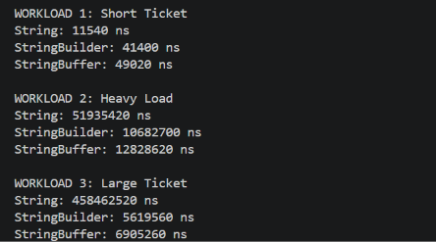

TASK 2

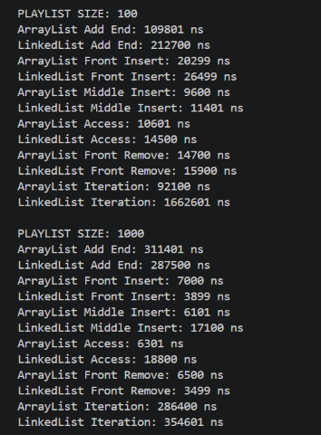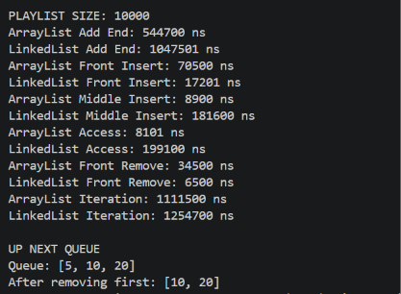

TASK 3

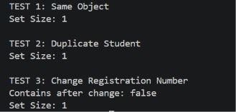

TASK 4

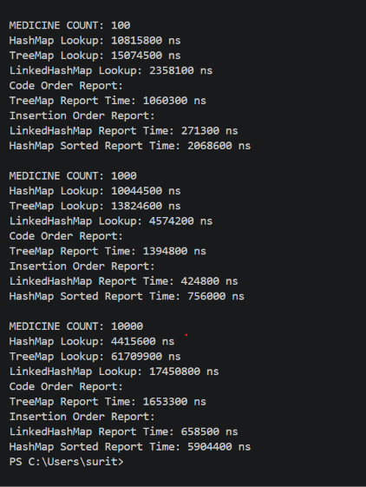

TASK 5

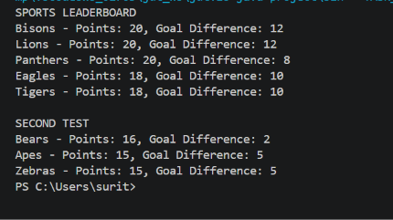

TASK 6

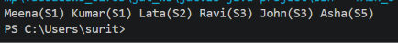

TASK 7

A. Diagnose the bottleneck – 2 marks
Original solution uses HashMap.
- HashMap does not guarantee sorted key order.
- To display medicine codes in ascending order, keys must be copied and sorted for every report.
- Sorting takes \(O(n\log n)\) time.
- If reports are generated repeatedly, the same sorting work is repeated unnecessarily.
- Bottleneck: Repeated sorting of medicine codes when generating inventory reports.

B. Define the design objective – 2 marks
The redesigned system must:
- Maintain medicine codes in ascending order.
- Avoid sorting the complete inventory every time a report is generated.
- Keep report generation at \(O(n)\).
- Preserve correct medicine-code ordering.

C. Design the revised solution – 4 marks
Original design:
- Store medicines in HashMap.
- Copy all keys into a list.
- Sort the list.
- Display medicines in sorted order.
Redesigned solution:
- Store medicines in TreeMap.
- TreeMap automatically maintains keys in sorted order.
- Iterate directly through the TreeMap to generate reports.
Pseudocode
Create TreeMap

For each medicine:
Insert medicine code and details

For each report:
Traverse TreeMap in sorted order
Display medicine details
Complexity comparison:
- HashMap insertion: average \(O(1)\)
- HashMap report with sorting: \(O(n\log n)\)
- TreeMap insertion: \(O(\log n)\)
- TreeMap report: \(O(n)\)
- Both designs use \(O(n)\) storage.
Trade-off: TreeMap insertion is slower than average HashMap insertion, but repeated reports become more efficient.

D. Predict before implementing – 1 mark
Before testing, my prediction is:
- For small inventories, both designs may perform similarly
- As the inventory grows, TreeMap should generate repeated reports faster because it avoids sorting every time.
- TreeMap insertion may take more time than HashMap insertion.

E. Implement and validate – 2 marks
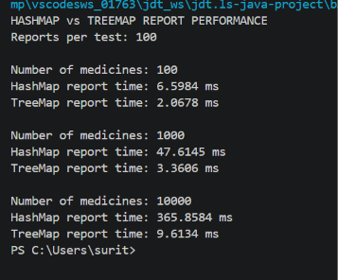

Both methods process the same medicine data and produce the same checksum. The program measures report-generation time only; it does not include insertion time.

F. Defend the final design – 2 marks
Use your measured results to complete this evaluation:
- Prediction: The prediction was supported if TreeMap generated repeated reports faster, especially for larger inventories.
- Improvement: Compare the measured HashMap and TreeMap report times for 100, 1,000 and 10,000 medicines.
- New cost: TreeMap requires \(O(\log n)\) insertion instead of average \(O(1)\) insertion in HashMap.
- Original design is preferable when: Reports are rarely generated, fast insertion and lookup are more important, and sorted output is not required.
Final conclusion:
TreeMap is suitable for a pharmacy inventory system that frequently generates reports in medicine-code order. It avoids repeatedly sorting the keys and maintains sorted order automatically. HashMap is still preferable when fast insertion and lookup are the main requirements and sorted reports are unnecessary.

